**Data base Project**

If the post deployment scripts have been written you can re publish the same data base over top of an earlier version of the data base.

1. 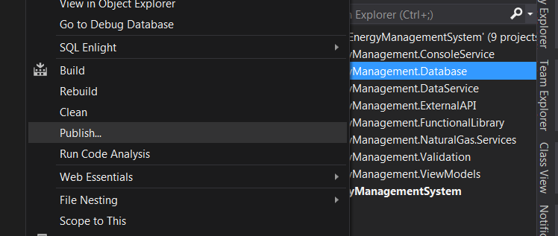
   1. Right click on the data base project
   2. Left click on publish
2. 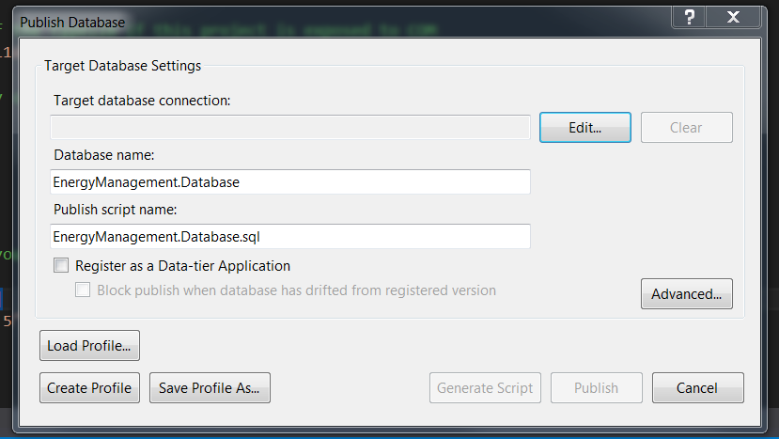
   1. Click edit and select the target database
3. 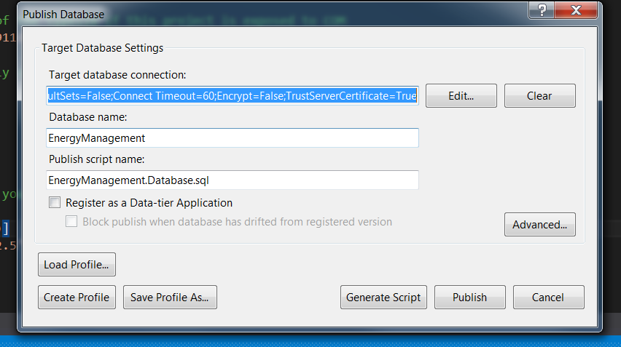
   1. Click Advanced
4. 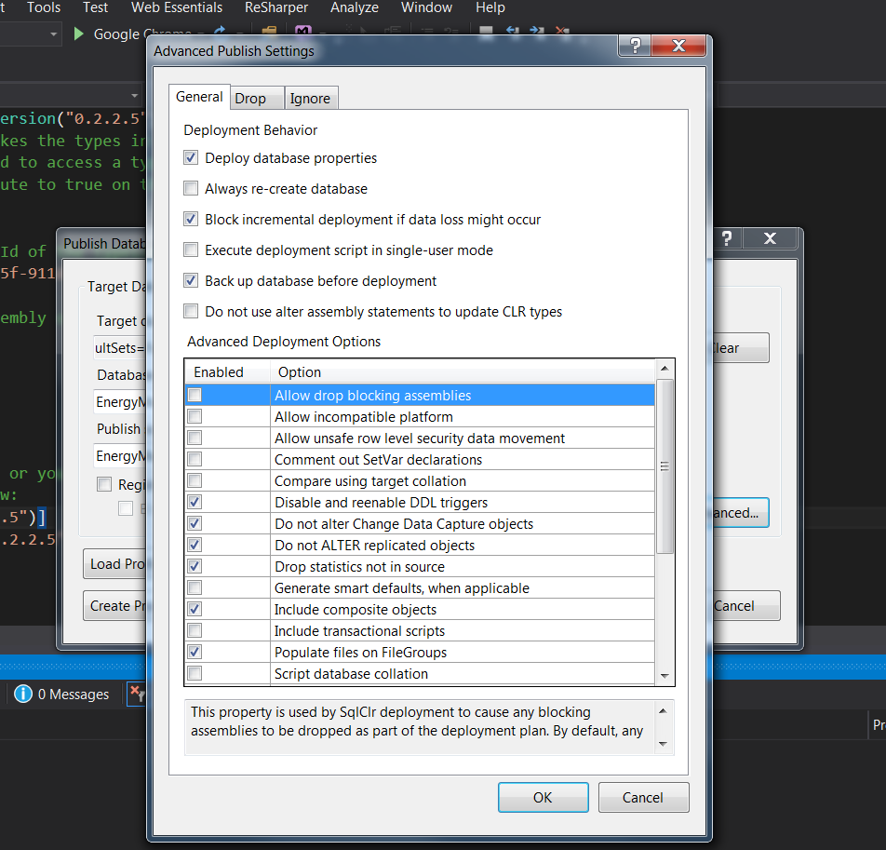
   1. Be sure to check the back up data base before deployment and click ok
5. Then Click Publish
6. 
   1. If it’s successful it will tell you otherwise if you see any errors it should roll back to the backup.